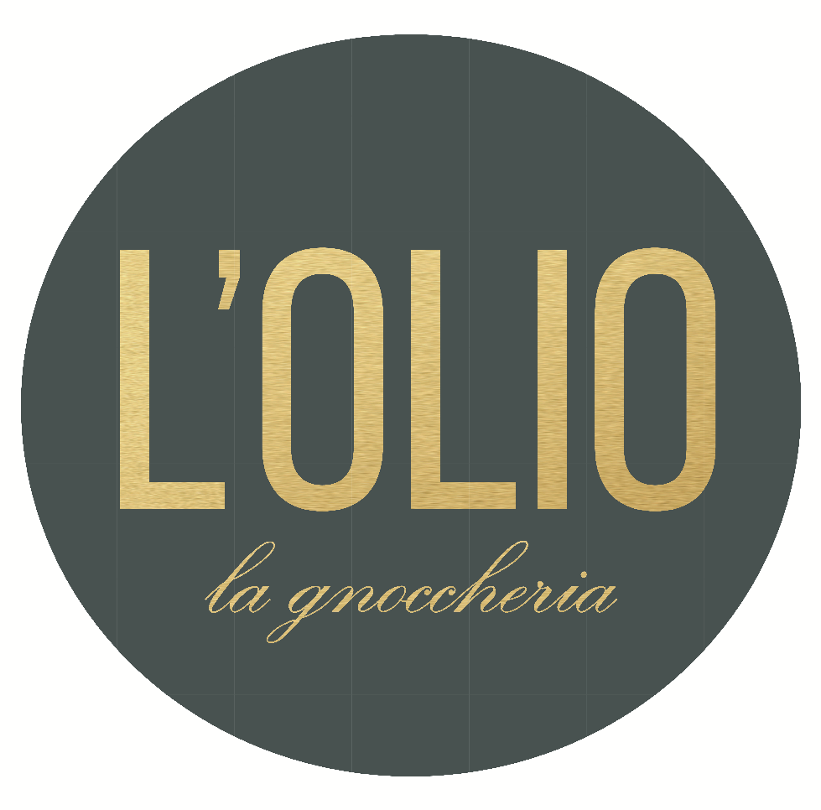
L’Olio Group Booking Form

NAME: _______________________________DATE: ________________ PH: _________________________ EMAIL: ________________________________
OCCATION: ____________________________________________________________________________________________________________________

PLEASE INDICATE YOUR MENU CHOICE FROM OUR SET MENU OR AL A CARTE MENU.
SET MENU NO#__________ Deposit:_______________________________________

BREADS: (CHOICE NO.1) ___________________________________
(CHOICE NO.2) __________________________________
ENTREE: SERVED ON PLATTERS (CHOICE NO.1) _________________________________ ___
(CHOICE NO.2) ________________________________ __
(CHOICE NO.3) _________________________________ __
(CHOICE NO.4) _________________________________ __
PASTAS: PLATTERS (CHOICE NO.1) ____________________________________
(CHOICE NO.2) ____________________________________
(CHOICE NO.3) ____________________________________
MAINS: (CHOICE NO.1) __________________________________ _
(CHOICE NO.2) _____________________________________
SALADS: SHARED (CHOICE NO.1) ________________________________________
DESSERT: SERVED ALTERNATE (CHOICE NO.1) ________________________________ __
(CHOICE NO.2) ______________________________________
ADD ON: SERVED ON PLATTERS (CHOICE NO.1) ________________________________________
(CHOICE NO.2) _________________________________________
BEVERAGES: Please circle one choice ON CONSUMPTION / BEVERAGE PACKAGE
CONFIRMATION OF NUMBERS: ADULTS: SPECIAL MENU: KIDS U/10: HIGH CHAIRS___________
PLEASE SIGN HERE: PRINT HERE:
CBA BANK DETAILS: BSB – 062 323 AC- 10192098 NAME- LOLIO
PLEASE FORWARD REMITTANCE TO : info@lolio.com.au with your name and function date

BEVERAGE PACKAGES
Beverages are not included in the set menu prices. No BYO. Alternatively, we offer fixed price beverage packages
PACKAGE A- $34 PER PERSON – 3 HOURS ($11 PER ADDITIONAL HOUR)
Includes bottled house red and white wines, Corona, Peroni, Peroni Leggera, bottled sparkling & still water, and jugs of coke, lemonade & juices.
SOFTDRINK PACKAGE - $18 PER PERSON – 3 HOURS ($6 PER ADDITIONAL HOUR)
Includes bottle still & sparkling water, jugs of coke, lemonade & juices
KIDS DRINK PACKAGE - $15 PER PERSON ($5 PER ADDITIONAL HOUR)
Includes bottle still & sparkling water, jugs of coke, lemonade & juices
BAR TAB AVAILIBLE ON REQUEST
PLEASE ASK OUR EVENT COORDINATOR IF YOU WISH TO HAVE BOTTLES OF SCOTCH ON THE TABLE

TERMS & CONDITIONS
1. Set menus are only offered to groups with 10 or more guests.
2. Menus are customizable, however any changes are subject to a quote
3. We require sufficient notice at the time of booking to accommodate guests with special dietary requirements, such as vegetarians and people with gluten allergies. Late notice will incur additional fees.
4. A deposit is required to confirm your reservation. $100 for 10-25 people; $300 for 25-50 people; and $500 for 50 or more people. The deposit is not refundable if the function is cancelled within 4 weeks of the confirmed date.
5. Final guest numbers must be confirmed no later than 48hrs prior to the function date. You will be charged according to the confirmed numbers, regardless of late changes or guests which are unexpectedly absent. If numbers increase on the day, you will be charged accordingly.
6. Cake Service of $2 per person to cut and serve the main cake, any additional cakes & biscuits will be an additional charge.
7. All bookings from Monday – Saturday will incur a 5% surcharge.
8. All functions are limited to 4 hours from the time of booking; each additional hour will incur a room hire fee of $250 per hour.
9. All functions are given complimentary baskets of bread, any additional baskets will incur a fee of $3 per basket
10. Only bottled still and sparkling water is served for functions.
11. Table cloths & cloth napkins are used depending on guest numbers and are charged according to quantity.
Sundays and Public Holidays
- 10% surcharge is applicable to all bookings on Sundays & 15% surcharge is applicable to all bookings on public holidays
- Sunday Functions require a minimum of 35ppl to open. If numbers are less please don’t hesitate to call us, as we may be able to accommodate you if there are other bookings

