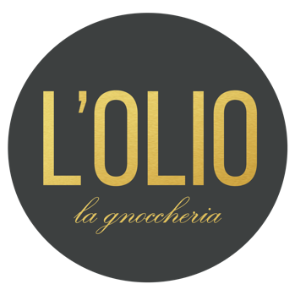

VALENTINE’S DAY – A LA CARTE AT L’OLIO

BOOKINGS ONLY FROM 5PM

Sunday 14th February, 2021

$50 per person minimum food spend | Deposit of $100 per table

PLEASE NOTE:

In order to confirm and secure your booking, L’Olio La Gnoccheria requires a signed booking form and pre-payment of $100. Bookings are not confirmed until L’Olio La Gnoccheria receives the signed booking form and pre-payment has been made.

This Valentine’s Day, dining at L’Olio La Gnoccheria is a la carte. We have a minimum food spend of $50 per person for all bookings.

The pre-payment deposit is non-refundable and will be deducted from your total bill at the end of the night.

Should you wish to cancel within 24 hours of 5pm on Sunday 14th February, 2021, L’Olio La Gnoccheria reserves the right to refuse a refund as this is outside of our cancellation policy.

Please note a 10% surcharge applies on Sundays.

Kindly email your completed form to info@lolio.com.au

Thank you

BOOKING CONFIRMATION FORM

Booking Reference: Valentine’s Day

Guest Numbers:
Name:
Email:
Phone:
Payment Amount:
Name on Card:
Card Number:
Expiry Date:
CCV/Security Number:
Credit Card Type:

I confirm I have the authority to charge this credit card for the deposit and I agree to the personal information that I am providing. Valentine’s Day deposit it $100.

The following card charges will apply:

VISA/MASTERCARD: 1.2%
AMEX: 2.1%

Signature _________________________________________ Date _____________________

